Record web by Jmeter behind Bosch Proxy

1. Access to the folder where you store Jmeter -> Run CMD

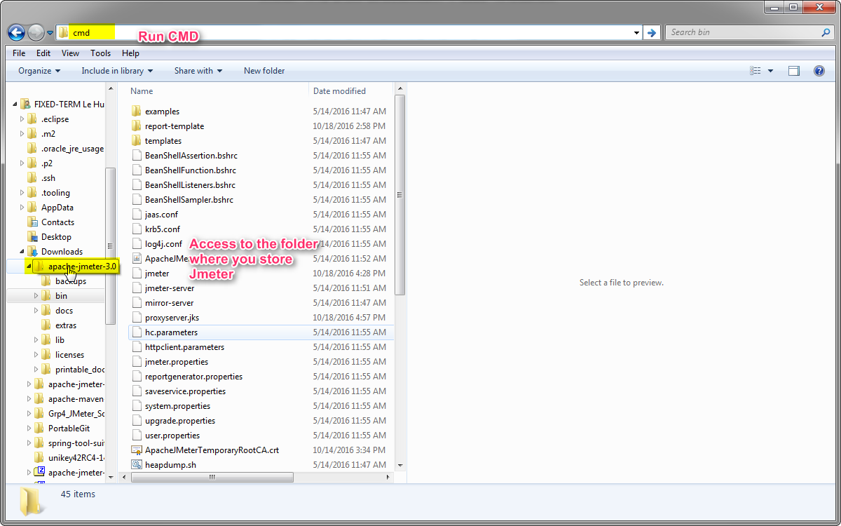

1. Run Jmeter with the command line

Jmeter –H rb-proxy-de.bosch.com –P 8080 –N localhost



1. 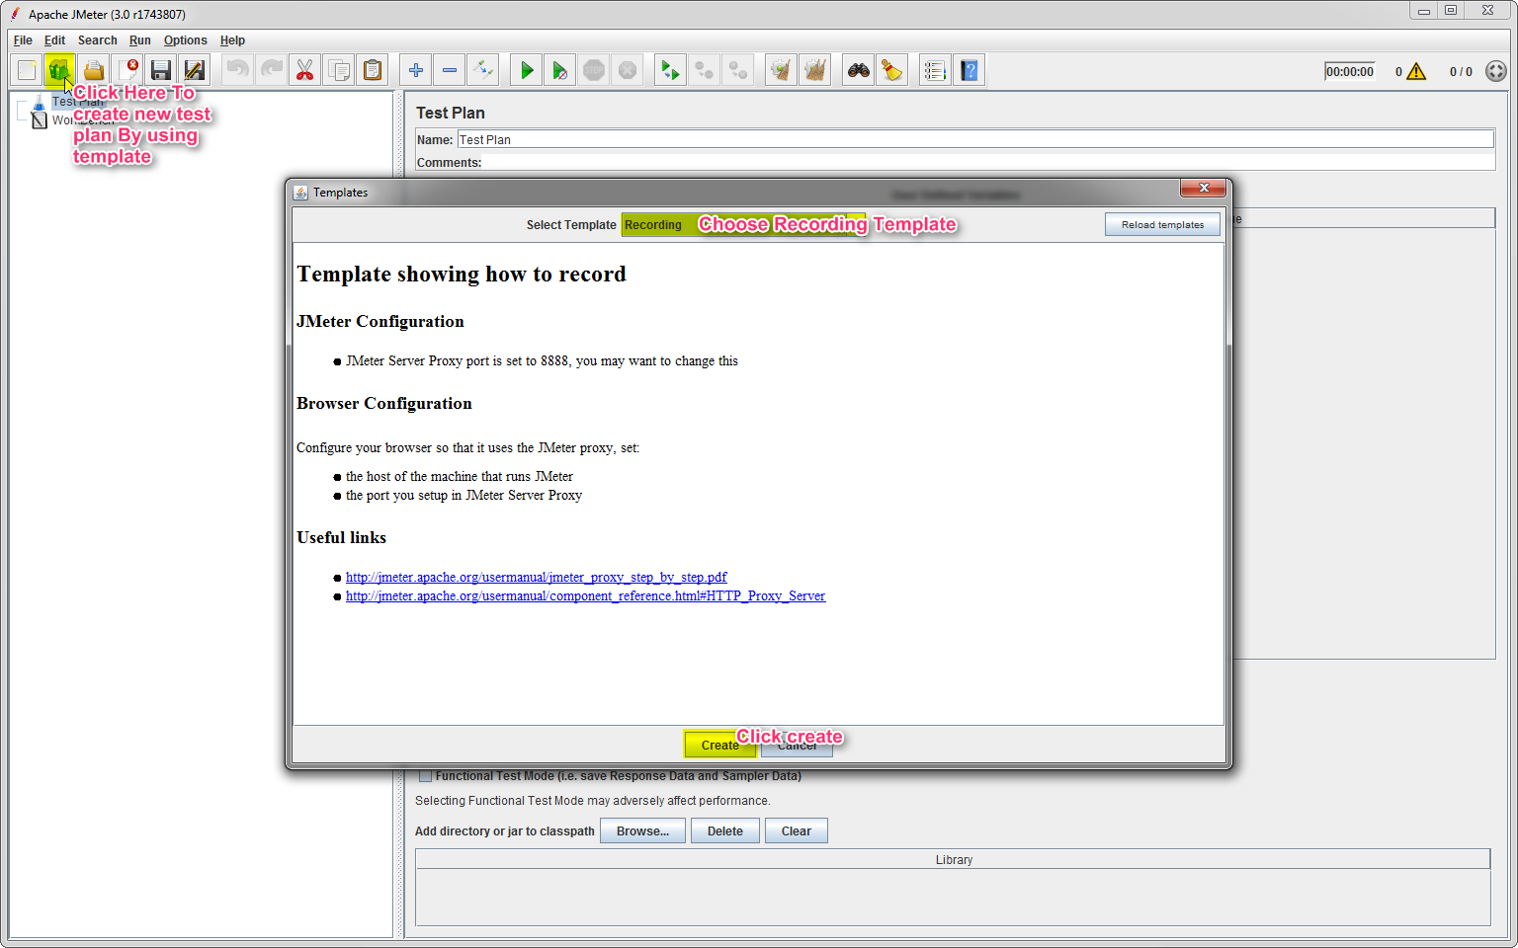

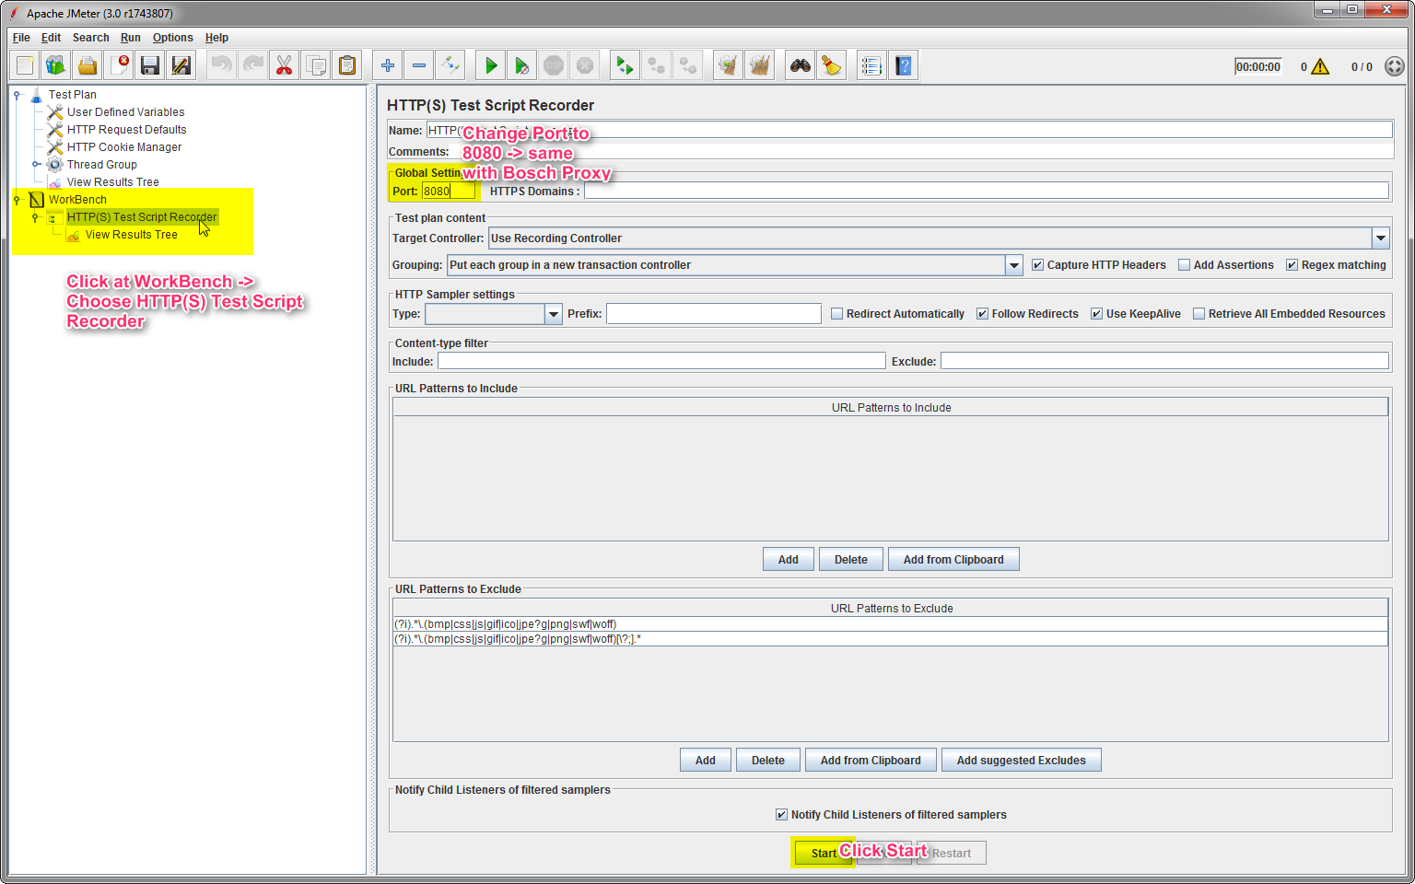

Then Click OK

1. Open the browser that you want to record, in this case I using IE

Open IE -> Click Setting -> Choose Internet options

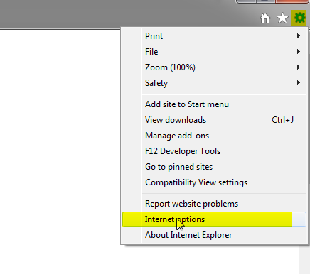

Click Connections Tab -> Choose Lan settings

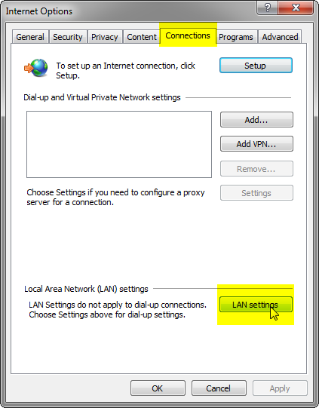

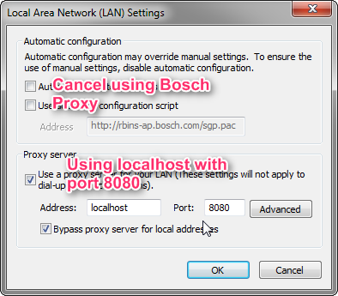

* Click OK

1. Add Jmeter Certificate to web Browser

Click on Content Tab -> Choose Certificates

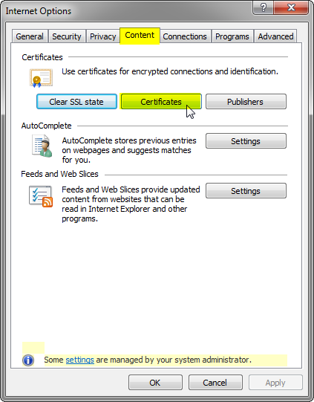

Choose Trusted Root Certification Authorities Tab -> Click Import

Click Next

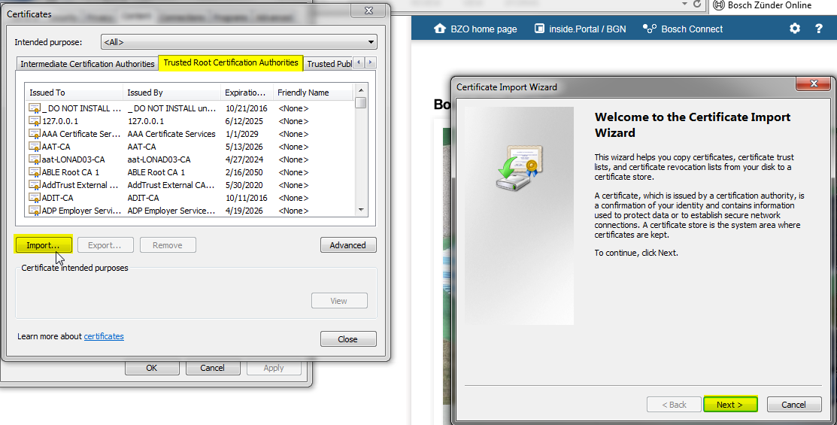

Click Browse -> choose ApacheJmeter….crt -> it was stored in Jmeter/bin Folder -> Click Open

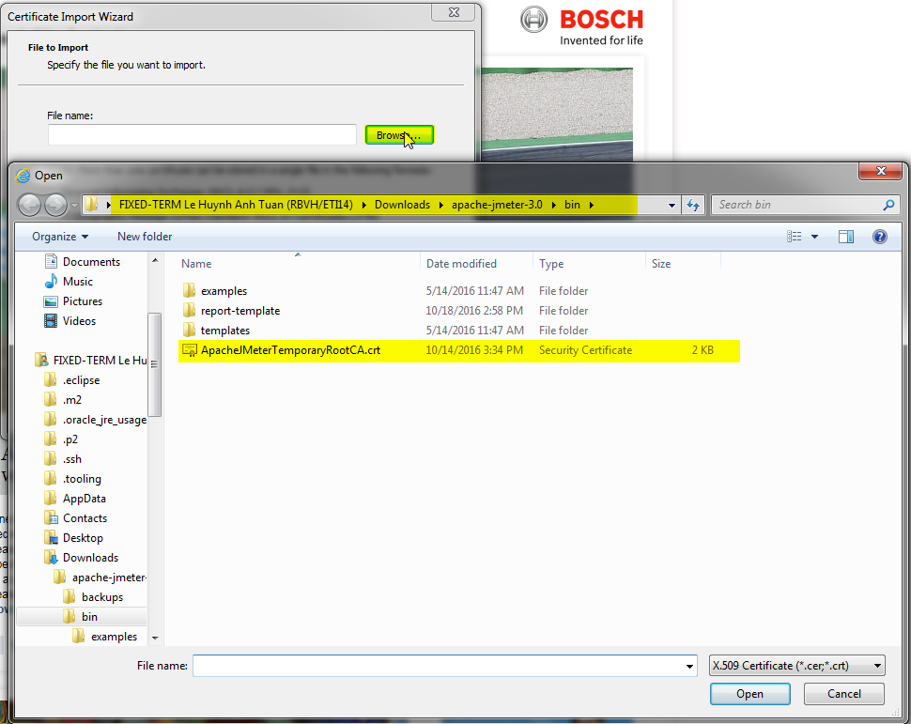

Click Next -> Next -> Finish.

Click Close -> OK.

You are already to record. Start your work and jmeter will automate recording your work. When you finish it, go back to Jmeter and Click Stop